

# LAB – FILE

**Graphics and Animation Tools - Lab**

**CSGG 4101**

Name – Rishank Gupta

Roll No. – R100217062

Sap id – 500062486

Course – B. Tech CSE-OSS

Batch – 2

*Under the guidance of…*

Dr.Durgansh Sharma

Associate professor

Department of Cybernetics

School of computer Science (Socs)

**Experiment- 6**

**Aim: - Design of 3D Hut using Blender.**

**Steps for designing the Hut**

**Step-1:** Open Blender

**Step-2:** Create a blank file and delete the default cube.

**Step-3:** Add a plane and scale it to an average area of a hut, using Shift+A>S.

**Step-4:** Switch to edit mode using TAB.

**Step-5:** Add some loop cuts using CTRL+R, to create a division of rooms inside the hut. Loop cuts are needed to be added with respect to X and Y axis.

**Step-6:** Now delete any one face to bring the plane in L shape and extrude (E) it with respect to the z-axis such that it is equal to the two floors.

**Step-7:** To make a triangular-domed roof, extrude from middle from both ends of the hut. Add a similar plane in between both floors to differentiate between them.

**Step-8:** Now add some pillars to the HUT by adding a plane first and then by scaling it with respect to z-axis. Now add the same pillar to every corner by just duplicating it. (shift+D)

**Step-9:** To create the roof, add a cylinder apart from the hut. Switch to wireframe mode and select the half of cylinder and delete the vertices. Now duplicate it using (shift+D) and rotate it 180 degree and align both cover each other. Now add an array modifier (x-axis) and increase the number according to the length of the roof. Add a second array modifier (y-axis) and increase the number according to the breadth of roof.

**Step-10:** Add the same to the top of hut by tilting it according to shape of the hut. And add the copy of same to other parts of roof.

**Step-11:** Now add a camera and a light source to it. And arrange the camera to the best fit view.

**OUTPUT SCREEN:**

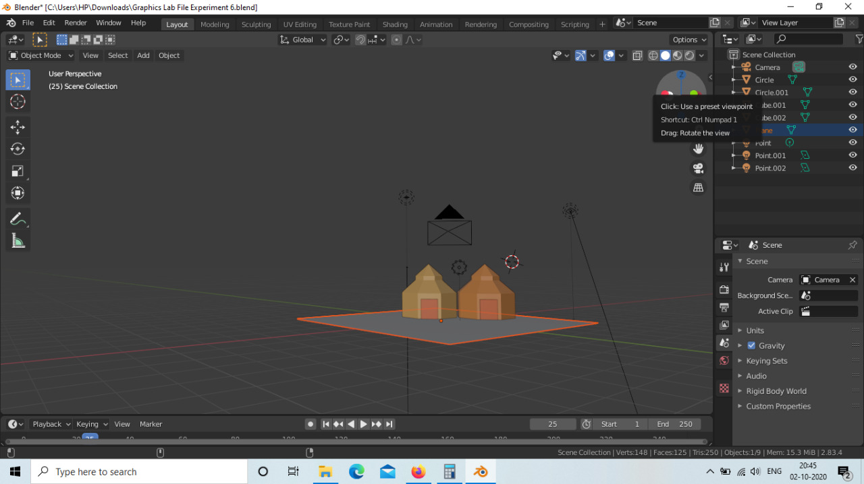

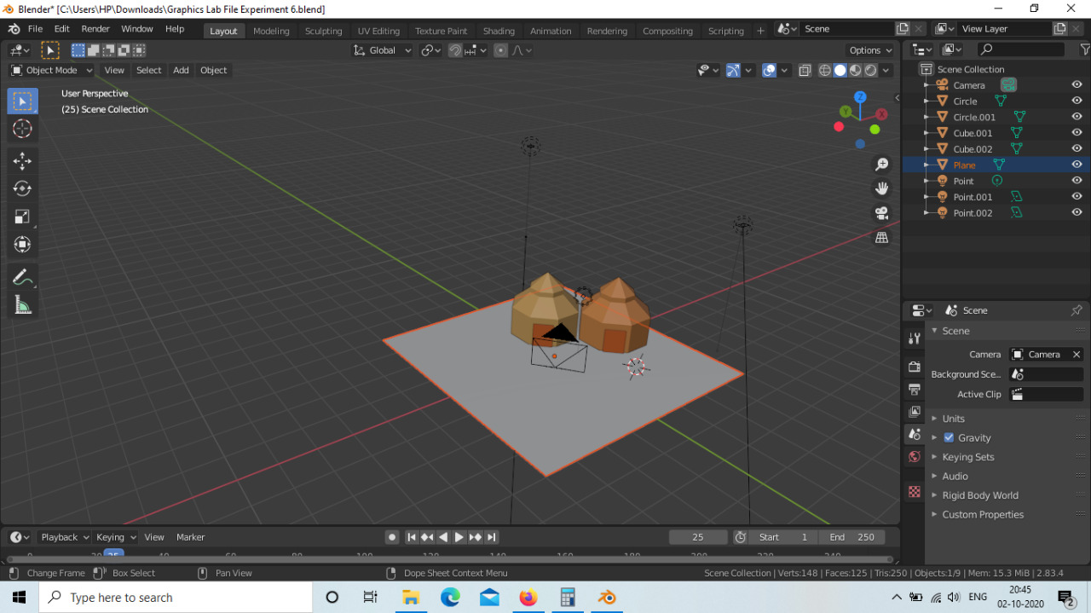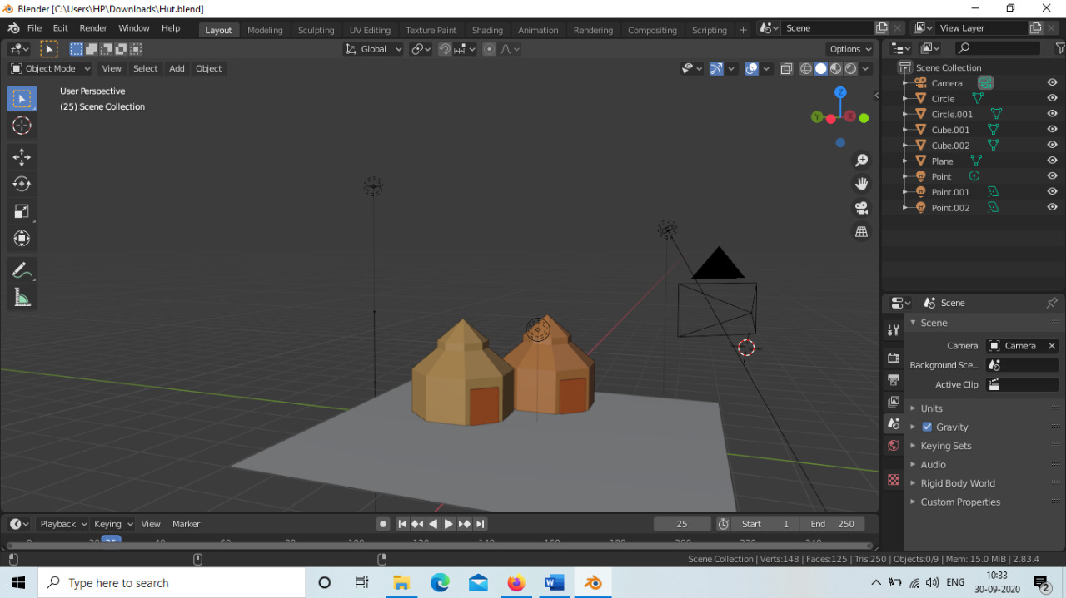

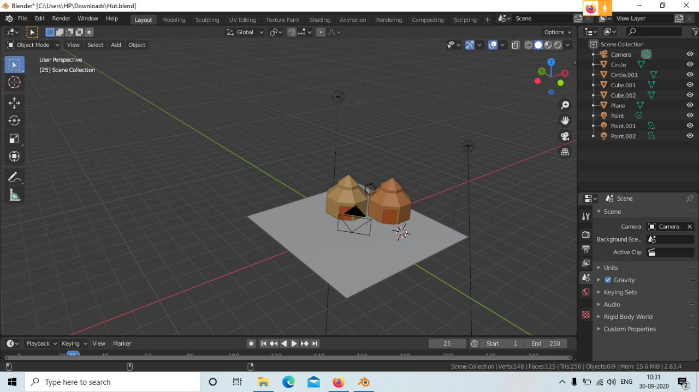

**Link:** [**https://drive.google.com/drive/folders/11lcU-TyHfFl9oVKzBFCXJzxsOgsjudEZ?usp=sharing**](https://drive.google.com/drive/folders/11lcU-TyHfFl9oVKzBFCXJzxsOgsjudEZ?usp=sharing)